Developmental Language Disorder (DLD) Awareness Day
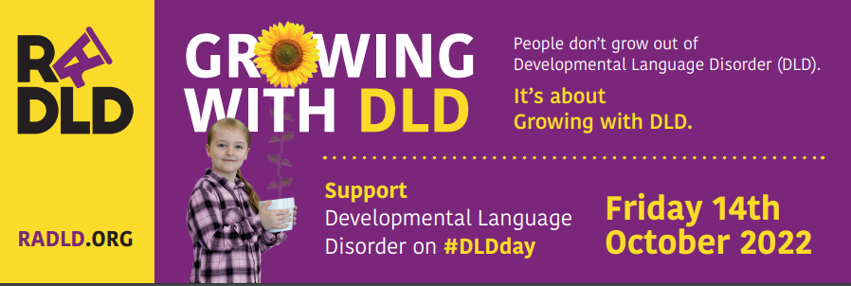
Do you have a minute….?
Read time: 1 minute
Developmental Language Disorder (DLD) is referred to as “The most common childhood disability you’ve never heard of.” because despite 7.6% of the population having it (that’s 2 pupils in every class of 30) many people have never even heard of it. We want to support you as SENCos to be a part of changing that. We know that the right support can make a difference to pupils with DLD.

The 2022 DLD day theme is Growing with DLD, highlighting that DLD is a lifelong, permanent disability. People do not grow out of DLD but with individualised support that can include regular speech-language therapy and educational adjustments they can thrive. It’s about growing with DLD.

Increased awareness of DLD can reduce social stigmatisation and improve access to specialist and support services.

Developmental Language Disorder Day (#DLDday), now in its sixth year, is celebrated annually around the world with more than 40 countries involved.

To support you in raising awareness in your school, even if time is limited, here a few resources that could be shared with staff to share the word about DLD and the significant and ongoing impact of a DLD diagnosis.

Resources
A resource and handout for teaching staff with things that can help pupils when communication gets hard. Read time: 2 minutes http://dldandme.org/wp-content/uploads/2021/01/DLD-Teacher-Handout.pdf
Key classroom strategies to support children with DLD. https://www.moorhouseschool.co.uk/_site/data/files/users/125779AF2E24CE9F5DDEEC30A047D36C.pdf
- Support strategies for teachers
- Read time: 1 minute
https://www.moorhouseschool.co.uk/_site/data/files/users/7A9C160FFA4F945992CDB7704ACDCB37.pdf
- Support strategies for parents
- Read time: 1 minute

Video Clips
Developmental Language Disorder 2min 51second clip
https://www.youtube.com/watch?v=MU1inVSISFo
Released for last year’s campaign, a vital overview
Living with Developmental Language Disorder 4 min 54 second clip
https://dldandme.org/topics/videos/
- Raises awareness around how bilingualism is not a cause of DLD, nor does it make it worse.
- Shares the impact upon a young person as a result of DLD, socially as well as academically.
- Explores the impact of differing responses to support
What families think about a Developmental Language Disorder diagnosis
2min 10 second clip
https://www.youtube.com/watch?v=kl6tiib_XFQ
Giving and receiving a diagnosis for a condition such as Developmental Language Disorder (DLD) is a big, and potentially scary step. To demystify this process RADLD asked families whose children had received a diagnosis of DLD what they thought.
Parent of a child with Developmental Language Disorder
3 minute 45 second clip
https://dldandme.org/topics/videos/
A parent shares their child’s experiences. The challenges and the compensatory strategies the young person has developed.

From a young person’s point of view
Lily Farrington’s Amazing Developmental Language Disorder Animation.
2 minute 1 second clip
https://youtu.be/rwOfkj0dj_0
A superb and succinct animation (made by Lily) explaining how DLD feels from a young person’s perspective.

Living with Developmental Language Disorder – DLD and Me
4 minute 24 second clip
https://dldandme.org/topics/videos/
The story of a young person diagnosed with DLD and the issues he has had to face in his journey through education and the impacts on his life outside of school.

A little more time…...?
The Talking DLD Podcast – The DLD Project – Vocabulary & DLD
50 minutes
Episode 10, Stephen Parsons and Anna Branagan, Speech and Language Therapists, trainers and co-authors of resources ‘Language for Thinking’ and Word Aware’ talk about classroom strategies for increasing learning.

Book – DLD , Why Can’t You See Me?
No time limit, enjoy at your leisure!
The author was diagnosed with Developmental Language Disorder (DLD) as an adult which inspired her to write the DLD; Why Can't You See Me? Poem. The poem has now been adapted into a children's illustrated book which aims to help raise awareness and understanding of DLD. The book gives readers a valuable insight, understanding, compassion and empathy for the daily challenge those with DLD may face.
Amazon – Paperback £12.99 or Kindle £9.99

Learn more about DLD day, DLD & RADLD at:
- WEBSITE: www.radld.org
- FACEBOOK: www.facebook.com/radld.page
- TWITTER: https://twitter.com/RADLDcam
- YOUTUBE: www.youtube.com/user/RALLIcampaign
- INSTAGRAM: www.instagram.com/radldcam/

