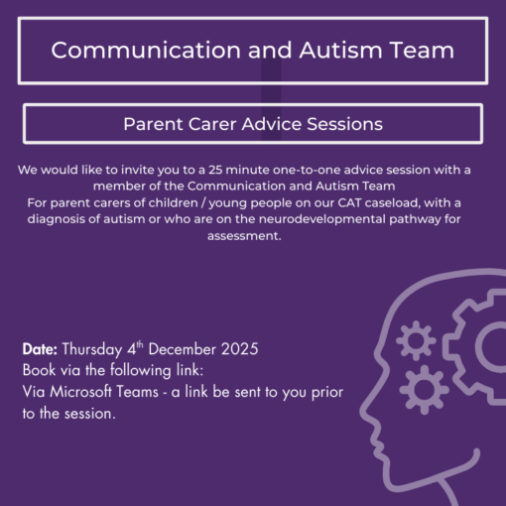
CAT Parent Carer Online Advice Sessions December 4th 2025 - Local Offer Birmingham CAT Parent Carer Online Advice Sessions December 4th 2025 - Local Offer Birmingham

