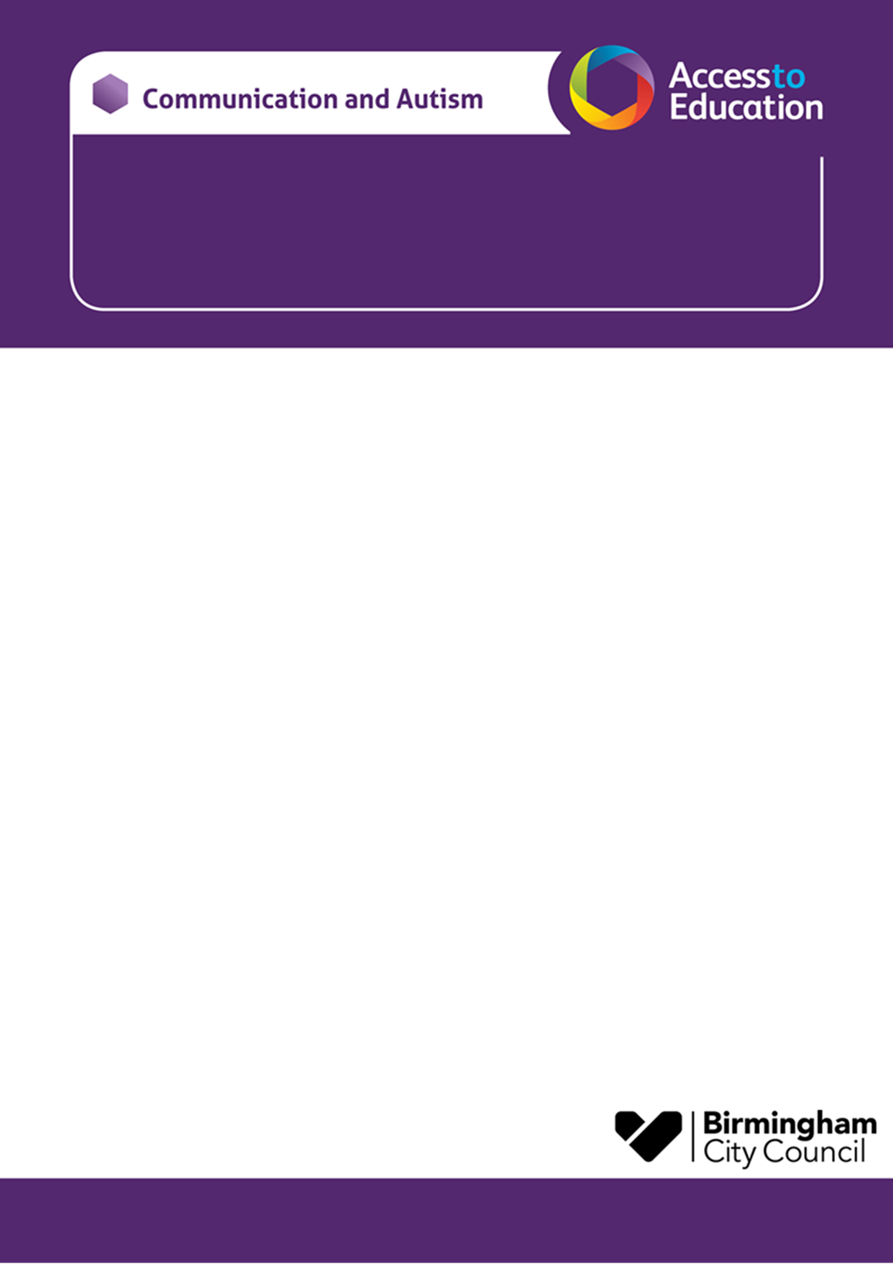

**Communication and Autism Team (CAT)**

**SUMMER 2025 - Parent carer Advice Sessions online**

We would like to invite you to a one-to-one advice session with a member of the Communication and Autism Team

For parent carers of children / young people on CAT Caseload with a diagnosis of autism or who are on the neurodevelopmental pathway for assessment.

|  |  |
| --- | --- |
| The sessions will take place online via Microsoft TEAM’s and will last for  25 minutes. | Sessions are available on the following date:  9th July 2025 9-12.30pm |

Due to very limited places, the sessions will be offered to the first families to contact us.

To reserve a place please visit the Birmingham local offer link here to book a session.

<https://www.localofferbirmingham.co.uk/product/parent-carer-advice-session-wednesday-9th-july-2025-900-1230pm/>

*If you secure a place, you will receive an email invite, to confirm your booking including the date and time of your session with CAT.*

Please include in your booking

* Your name – Parent carer
* Your Child’s name
* Your Child’s school
* Please include your preferred email contact for the TEAM’s invite to be sent to
* Add a brief description of the things you would like to talk about in the session, so that the CAT can prepare and make sure the advice is relevant to your child.

**Lisa Walmsley, Dawn Fisher and Julie Watchorn Brennan.**